**2.2.35 Analog-to-digital converters (ADCs)**

* Three 12-bit analog-to-digital converters are embedded and each ADC shares up to 16 external channels,
* Additional logic functions embedded in the ADC interface allow:
  + Simultaneous sample and hold
  + Interleaved sample and hold
* ADC can be served by the DMA controller
* analog watchdog feature allows very precise monitoring of the converted voltage
* interrupt is generated when the converted voltage is outside the programmed thresholds.
* ADCs could be triggered by any of TIM1, TIM2, TIM3, TIM4, TIM5, or TIM8 timer
* ADC input pins which should be configured as analog inputs

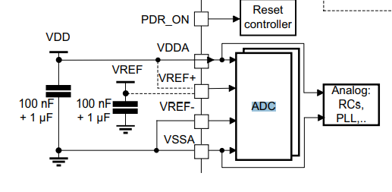

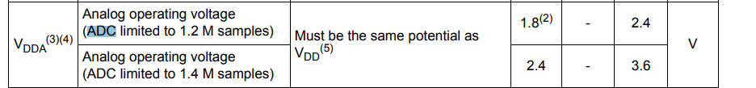

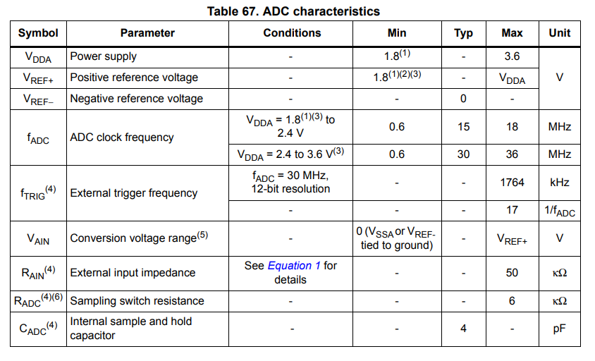

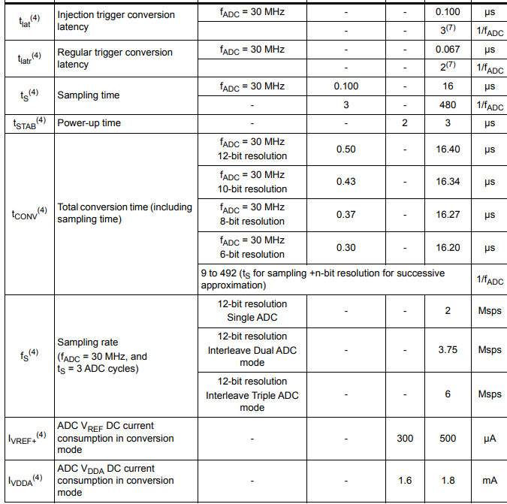

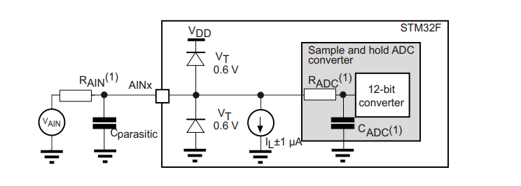

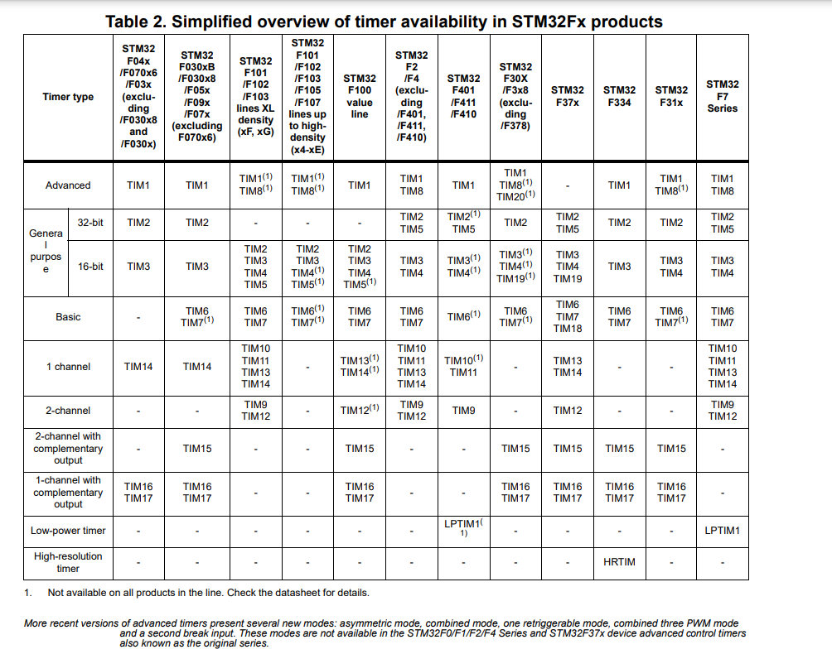

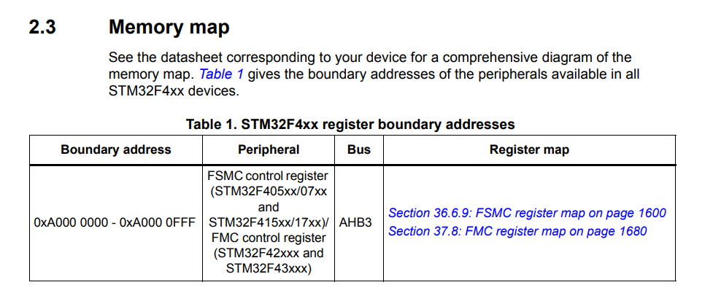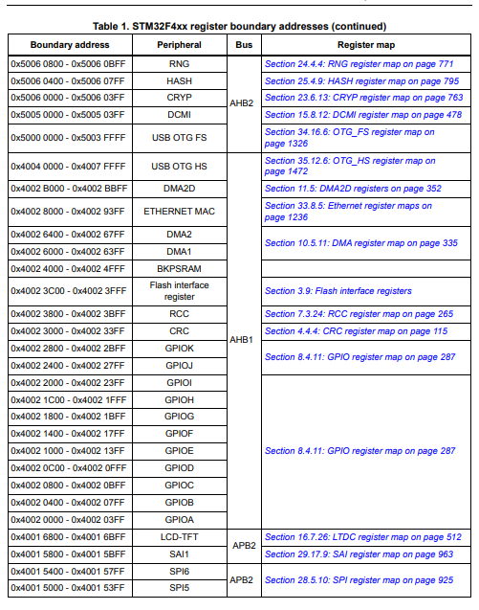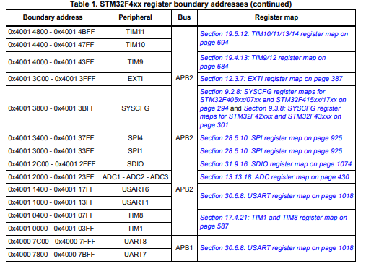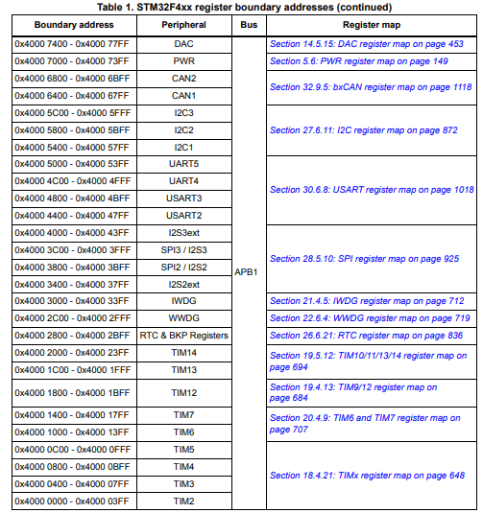

**BLDC motor:**

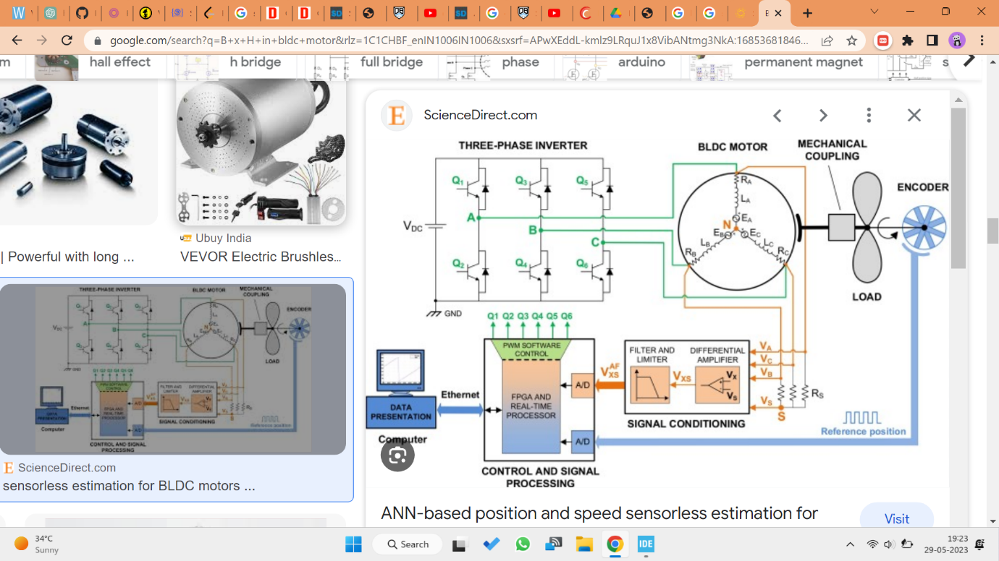

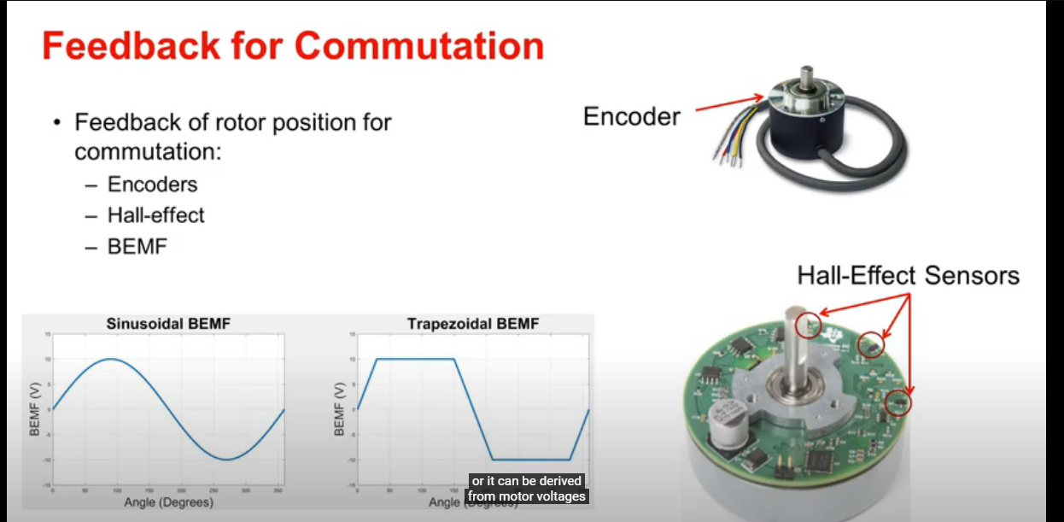

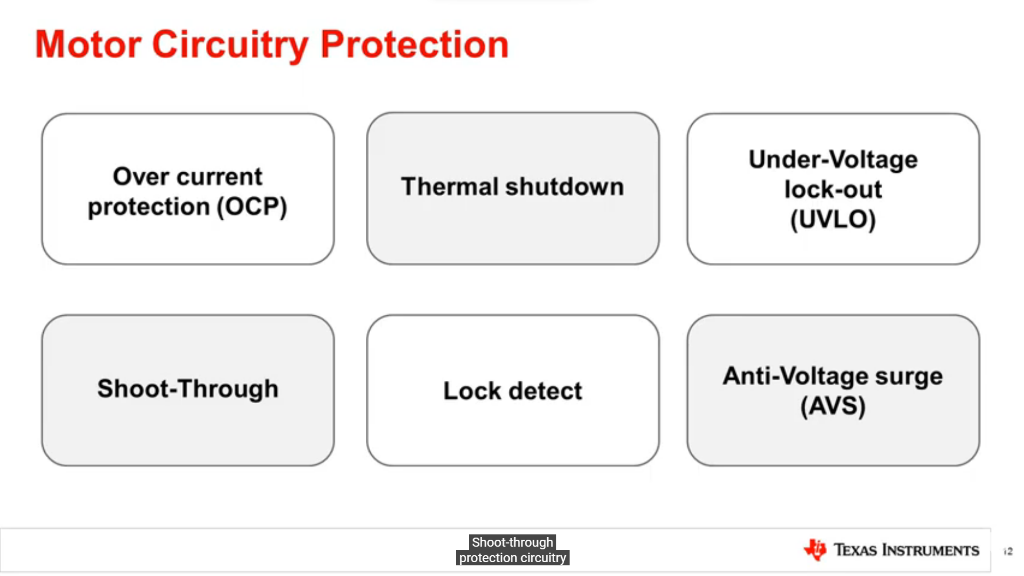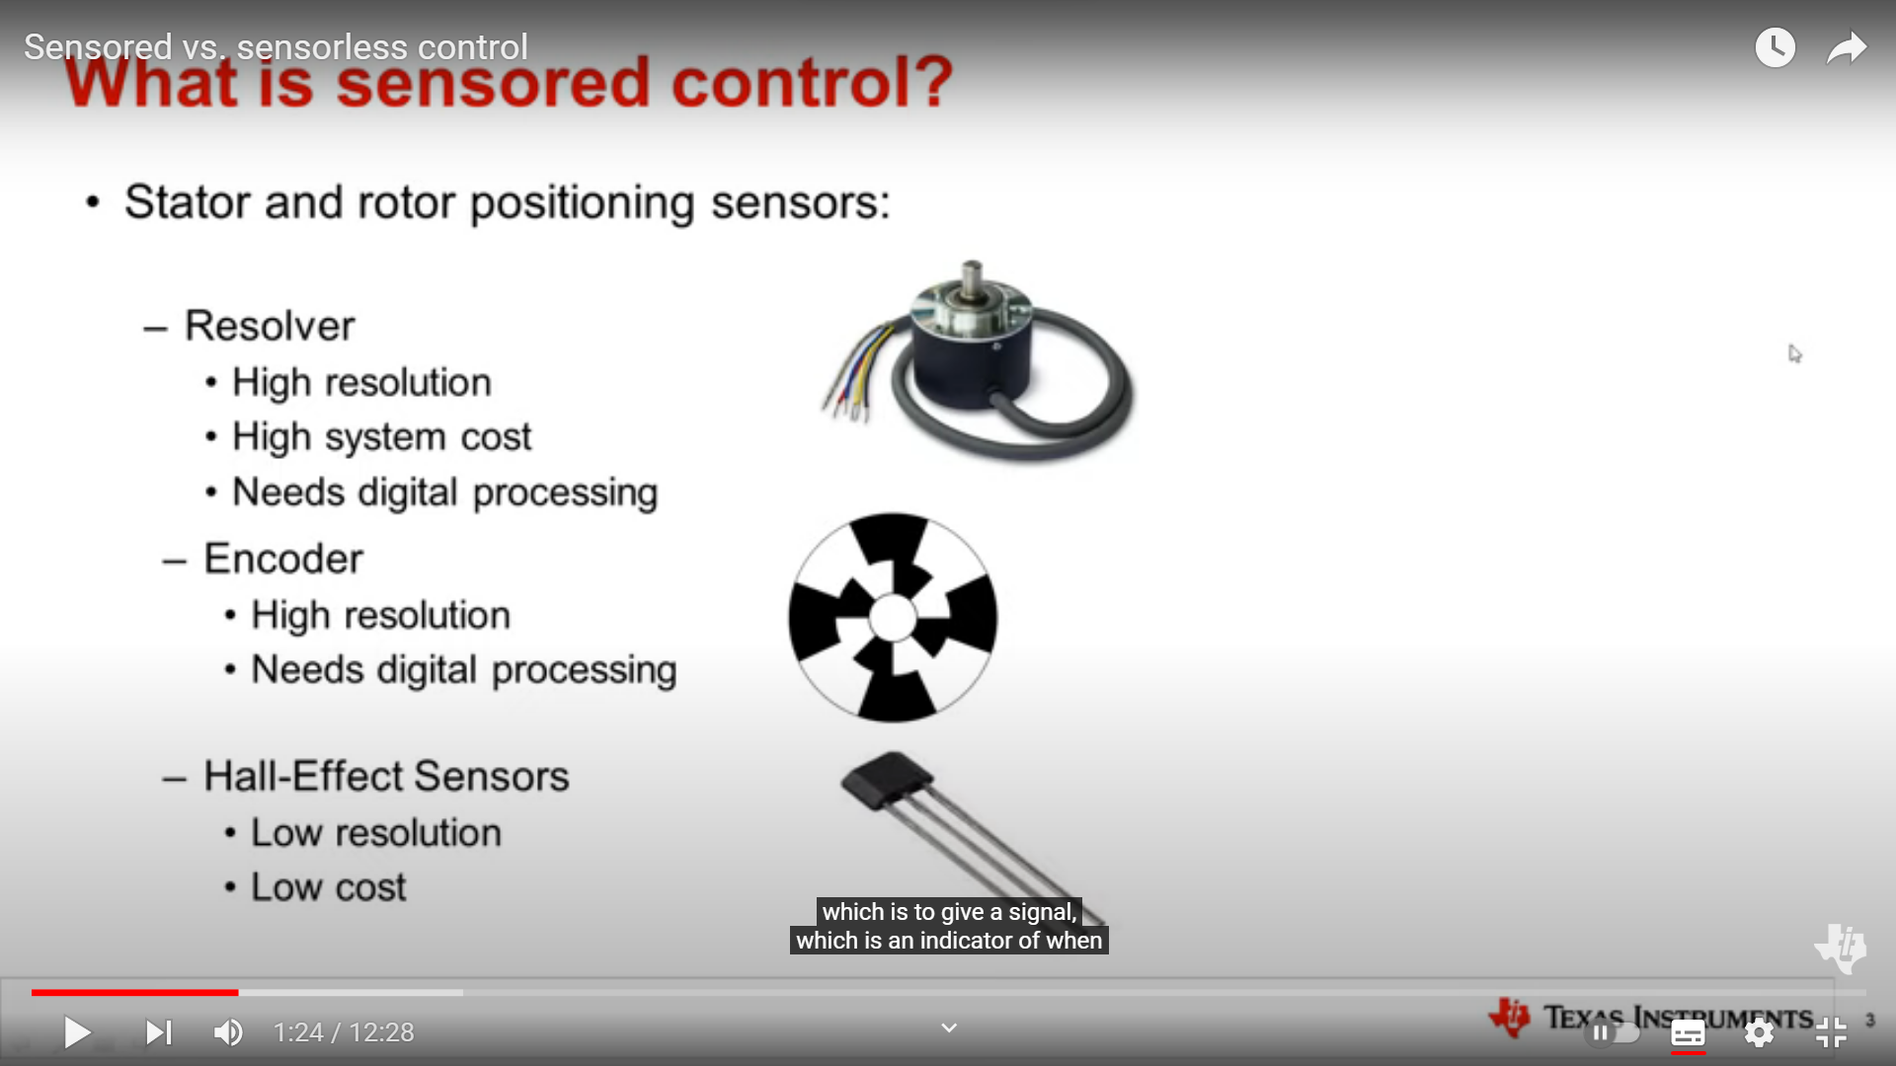

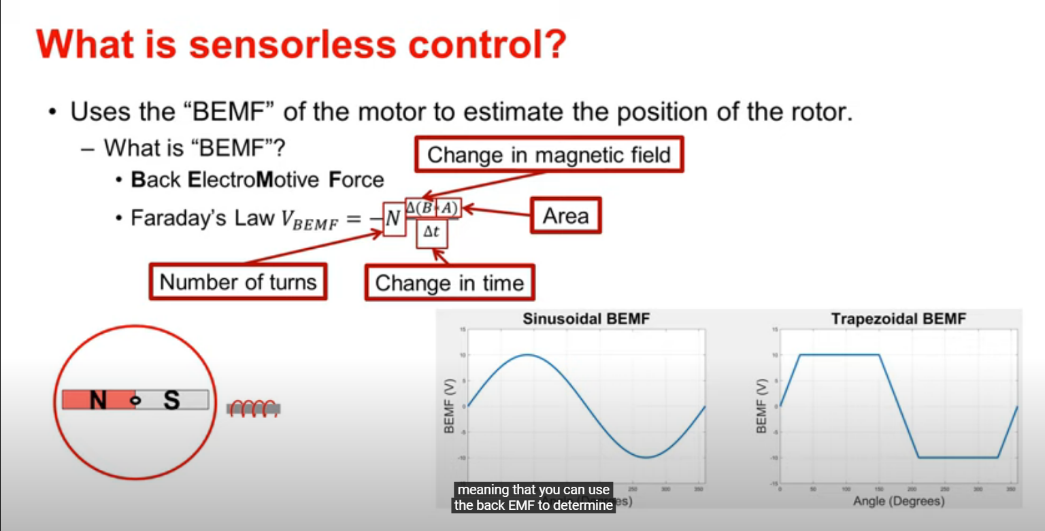

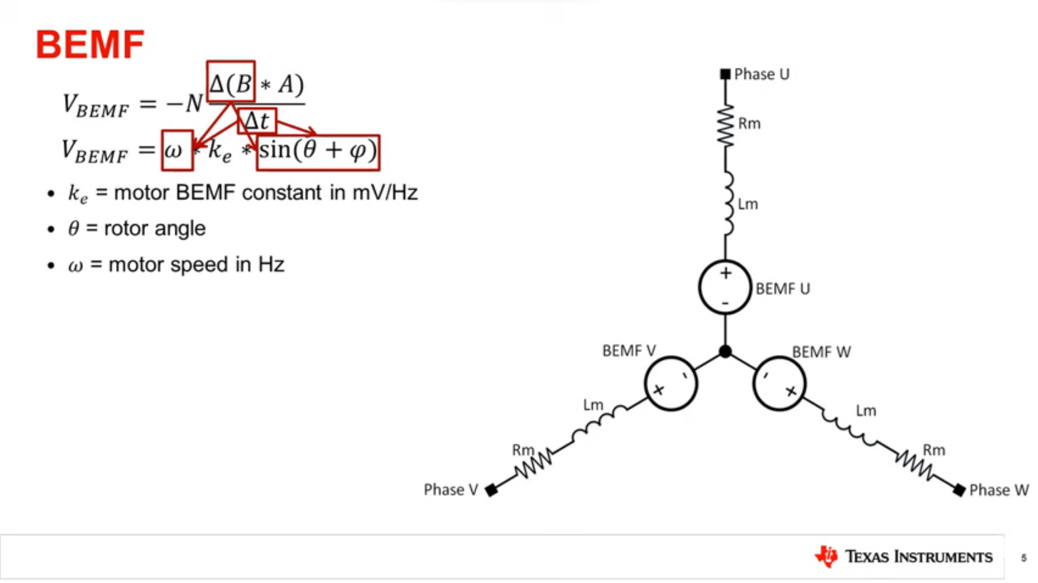

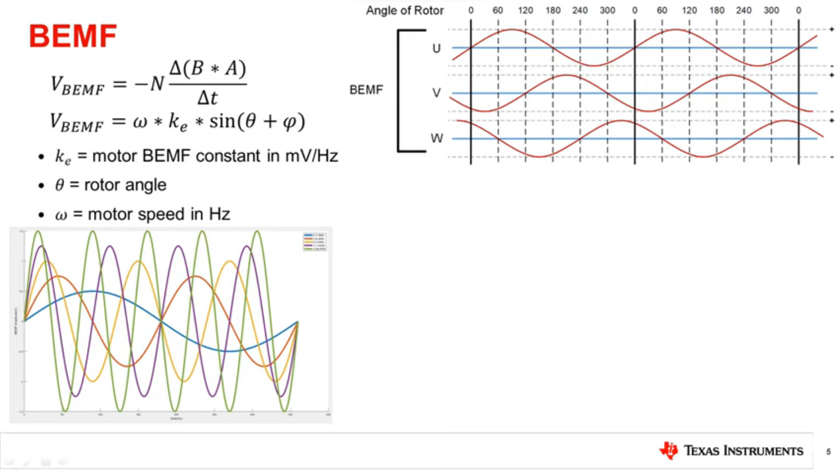

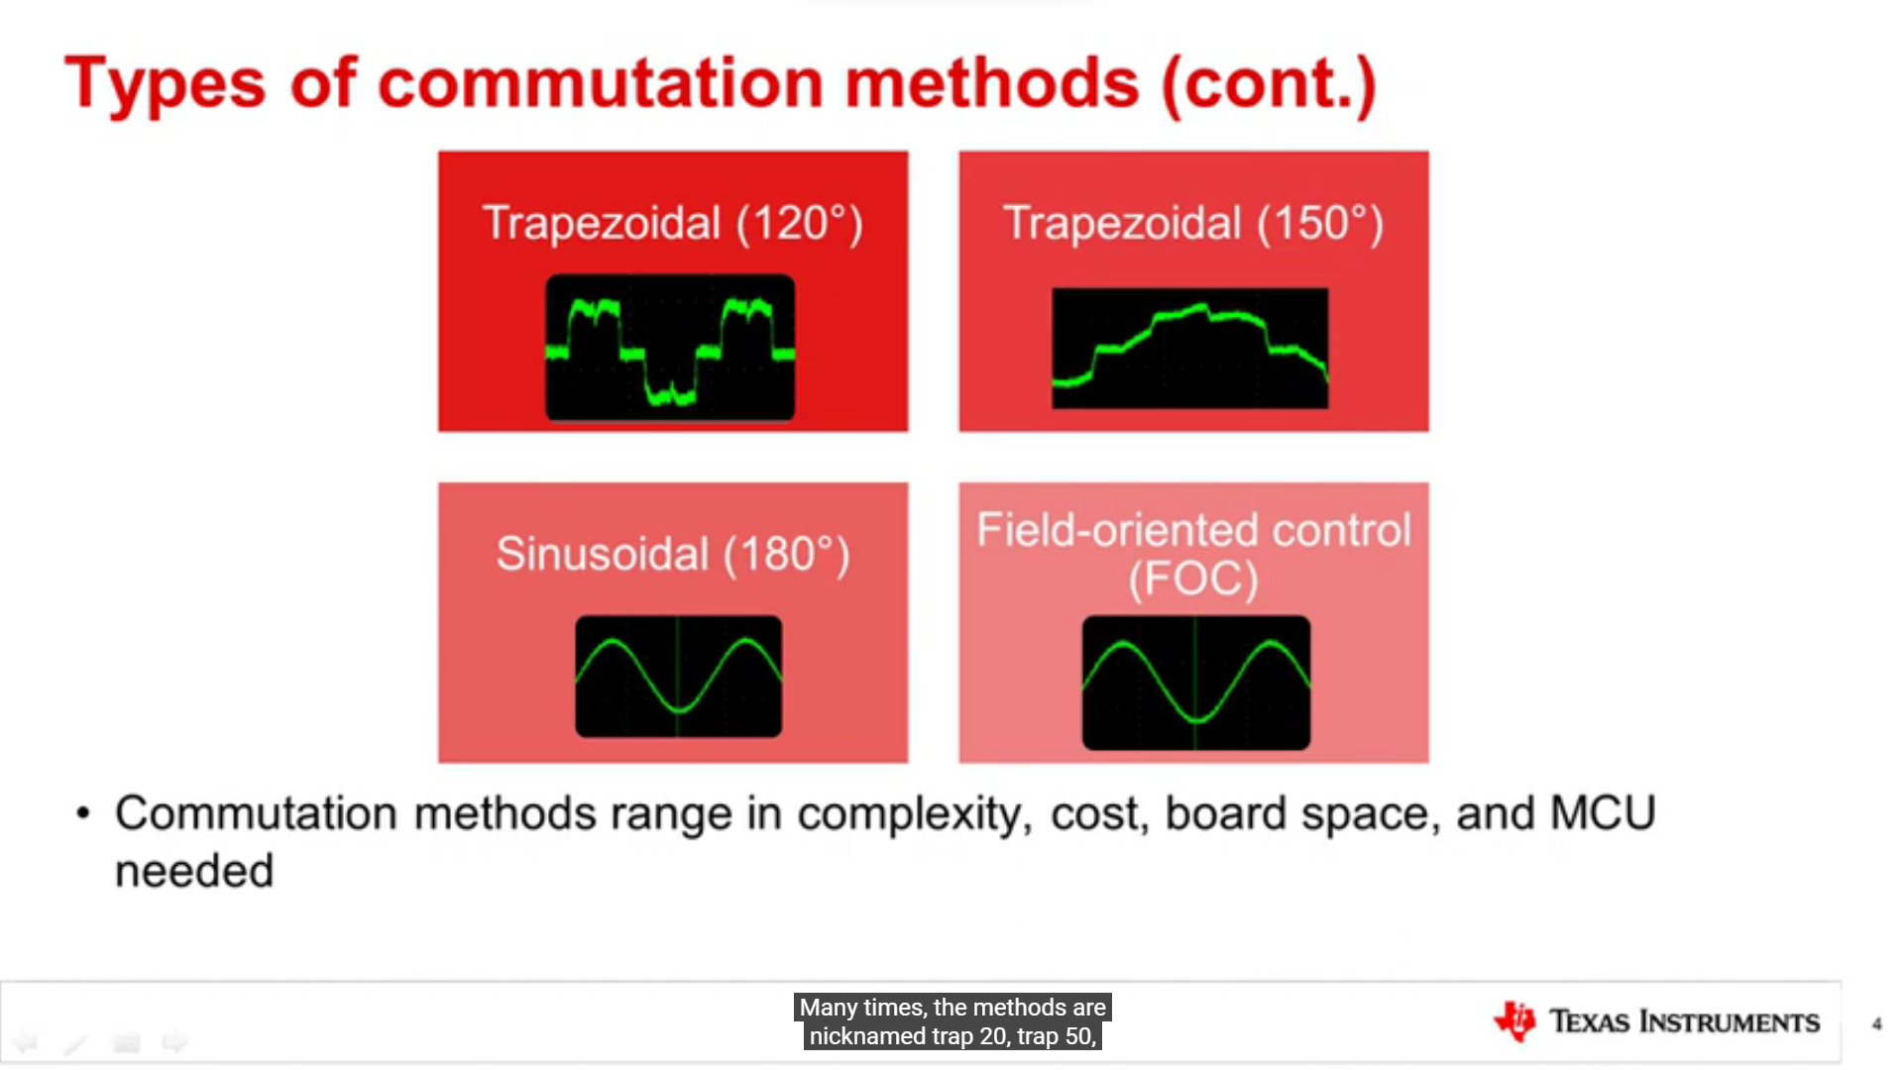

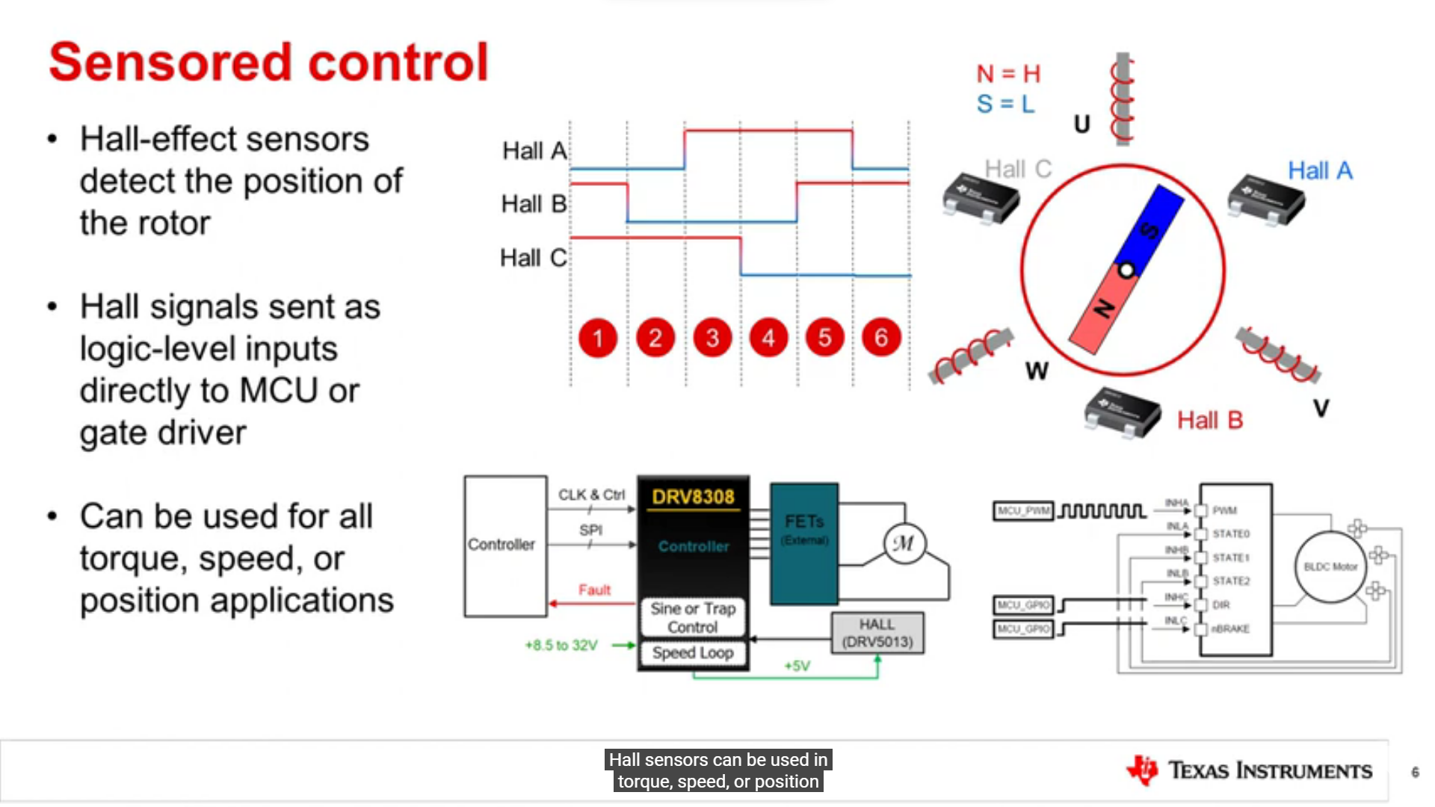

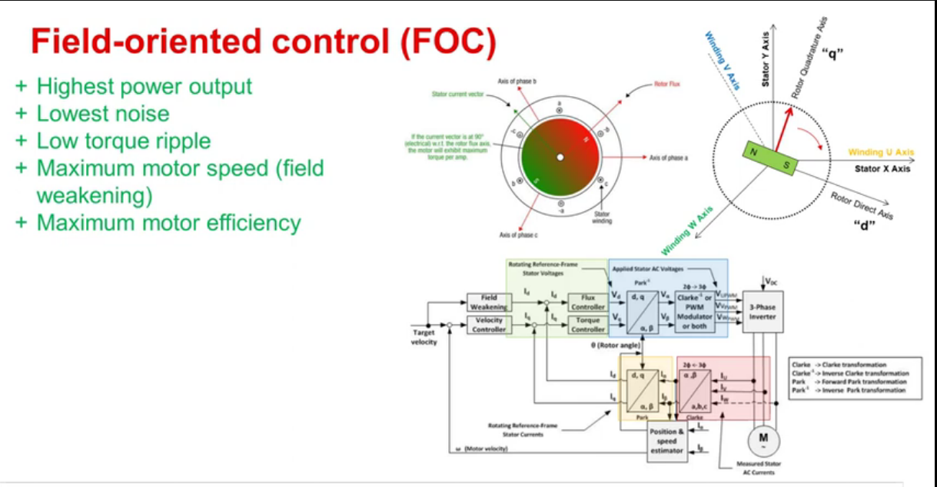

**BLDC Drivers :-**  
  
All available option for gate drivers :-  
<https://www.ti.com/motor-drivers/brushless-dc-bldc-drivers/bldc-drivers/products.html#89=Gate%20driver&2716max=95%3B102&>  
  
Kindly review this board, if it is possible to use for our motor  
It is titled as 48v but in it's feature it has some other spec. i request to check its data sheet :-  
<https://www.ti.com/lit/ds/symlink/drv3255-q1.pdf?ts=1686139664671&ref_url=https%253A%252F%252Fwww.ti.com%252Fproduct%252FDRV3255-Q1>  
  
also it's Evaluation board ;-DRV8305-Q1EVM Gate Driver Evaluation Module (EVM)  
<https://www.mouser.com/new/texas-instruments/ti-drv8305-q1evm-evaluation-module/>  
  
   
  
EVM Evaluation board:  
  
1). DRV8300DIPW-EVM  
* 6 - 100V Operation, 30A peak H-Bridge output current  * 6500Rs.  
<https://www.ti.com/tool/DRV8300DIPW-EVM>  
  
2). DRV8353Rx-EVM  
<https://www.mouser.in/new/texas-instruments/ti-drv8353rh-evm-drv8353rs-evm/>

3).DRV8312-C2-KIT

<https://www.mouser.in/ProductDetail/Texas-Instruments/DRV8312-C2-KIT?qs=%252BG2H6gVb6iyOUG85oF%2F6iQ%3D%3D>

<https://www.kynix.com/Parts/3581351/DRV8312-C2-KIT.html?utm_source=google&utm_medium=cpc&utm_campaign=P-Data_ADS/GA_4-0206-HP-2&utm_term=&adgroupid=&gad=1&gclid=CjwKCAjw1YCkBhAOEiwA5aN4AVrvKeGBEDceItnYIceWy-gzjyGXDEfZqBeWkVn-KS9HdEb0EHIqBxoCyHMQAvD_BwE>

4) DRV8350H-EVM

<https://www.ti.com/tool/DRV8350H-EVM>

5) DRV8353RH 10k Rs.

<https://www.ti.com/tool/DRV8353RH-EVM>

7) DRV8353RS-EVM 99$

<https://www.ti.com/tool/DRV8353RS-EVM>

**smoothing out adc voltage**

Kalman Filter: The Kalman filter is an optimal recursive filter that estimates the state of a dynamic system based on noisy observations. It is particularly useful for tracking and smoothing data in the presence of measurement noise. The Kalman filter takes into account both the current measurement and the predicted state to provide a more accurate estimation.

**………………………………………………………………**

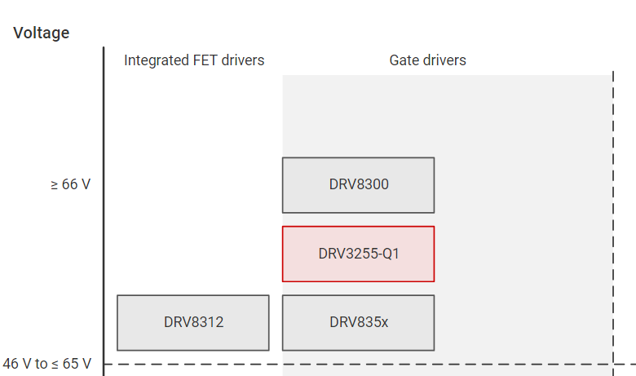

DRV8312 : Exact 70v Output , can't use

DRV3255-Q1 ( 0-48v ) : not in our Voltage Range ( 0-70v )

DRV8300 is already acceptable

DR8300:- <https://www.ti.com/product/DRV8300>

EVM :-

[DRV8300DIPW-EVM](https://www.ti.com/tool/DRV8300DIPW-EVM)

[DRV8300DRGE-EVM](https://www.ti.com/tool/DRV8300DRGE-EVM)

More Options….

DRV835x :

1. DRV8353RH-EVM 99$

<https://www.ti.com/tool/DRV8353RH-EVM>

DRV8353RS-EVM 99$

<https://www.ti.com/tool/DRV8353RS-EVM>

1. DRV8350H-EVM 99$

<https://www.ti.com/tool/DRV8350H-EVM>

DRV8350S-EVM 99$

<https://www.ti.com/tool/DRV8350S-EVM>

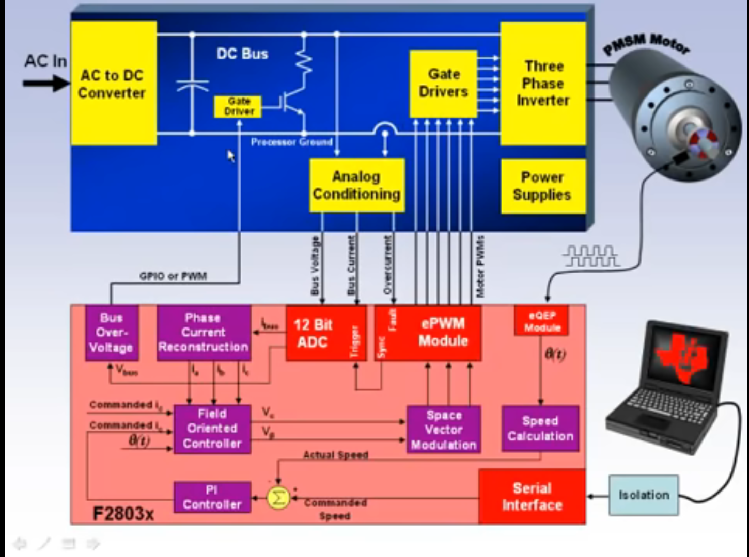

Red is hardware part

Puple is Software part